

**COLLEGE CODE : 1133**

**COLLEGE NAME : VELAMMAL INSTITUTE OF TECHNOLOGY**

**DEPARTMENT : ARTIFICIAL INTELLIGENCE AND DATA SCIENCE**

**STUDENT NM-ID : aut113323aib17**

**ROLL NO :113323243032**

**DATE :02.05.2025**

**Completed the project named as**

**COST ESTIMATION AND BUDGET ANALYSIS**

**SUBMITTED BY,**

**NAME : JANANI J**

**MOBILE NO : 7904321947**

**Title: Intelligent Cost Estimation and Budget Analysis System**

**Objective:**

Focuses on optmizing the performance of the cost estimation and budget analysis system. This includes refining estimation models, enhancing reporting capabilities, integrating real-time financial data sources, ensuring scalability, and strengthening data integrity and access control mechanisms.

**1. Cost Estimation Model Optimization**

**Overview:**

Estimation models will be refined to deliver more accurate cost predictions across diverse project types using historical data and predictive algorithms.

**Enhancements:**

* **Data Enrichment:** Broader datasets from past projects will be incorporated to improve model training.
* **Algorithm Tuning:** Statistical and machine learning models (e.g., regression, time series forecasting) will be optimized for accuracy and reliability.

**Outcome:**

Improved cost prediction accuracy, better handling of cost variability, and more confident decision-making during early project planning stages.

**2. Budget Tracking and Reporting**

**Overview:** The reporting engine will be enhanced to provide detailed and dynamic budget tracking in real-time.

**Key Improvements:**

* **Interactive Dashboards:** Implementation of dashboards to visualize budget status, cost overruns, and forecast trends.
* **Automated Alerts:** Budget thresholds and variances will trigger alerts for project managers.

**Outcome:**

More transparent budget oversight, faster decision-making, and timely identification of financial risks.

**3. Integration with Financial Data Systems**

**Overview:**

The system will integrate with ERP and accounting platforms to pull real-time expenditure and billing data.  
**Key Enhancements:**

* **API Optimization:** Streamlined data exchange with systems like SAP, QuickBooks, and Excel sheets.
* **Data Normalization:** Ensuring consistent formatting and alignment of financial data across sources.

**Outcome:**

Seamless data flow between systems, enabling real-time financial monitoring and consolidated budget views.

**4. Security and Access Control**

**Overview:**

As usage scales up, the system's data protection mechanisms will be hardened.

**Key Enhancements:**

* **Role-Based Access:** Access permissions will be aligned with user responsibilities to restrict sensitive financial data.
* **Audit Trails:** All budget modifications will be logged for transparency and compliance.

**Outcome:**

Improved financial data governance and compliance with internal audit standards.

**5. Performance Testing and Evaluation**

**Overview:**

The system's responsiveness and reliability will be evaluated under various load conditions.

**Implementation:**

* **Load Testing:** Simulate high transaction volumes to test system stability.
* **Usability Feedback:** Collect insights from finance teams to further enhance system effectiveness.

**Outcome:**

A robust, user-centric tool ready for deployment across departments or client sites.

**Key Challenges in Phase 4**

**1. Scalability:**

* **Challenge:** Handling growing volumes of financial data and user load.
* **Solution:** Backend optimizations and cloud-based deployment for elasticity.

**2. Data Integrity:**

* **Challenge:** Maintaining data consistency across multiple systems.
* **Solution:** Real-time sync and error-checking routines.

**3. Cross-Platform Compatibility:**

* **Challenge:** Integration with varied accounting tools.
* **Solution:** Flexible, modular API architecture.

**Outcomes of Phase 4**

**Enhanced Estimation Accuracy:** Cost predictions better aligned with actuals.

**Real-Time Budget Oversight:** Live insights into project spending.

**Secure and Scalable System:** Capable of supporting large, distributed financial operations.

**Next Steps**

The final phase will involve complete system rollout, user training, and post-deployment monitoring to capture feedback and ensure smooth adoption.

**Sample code**

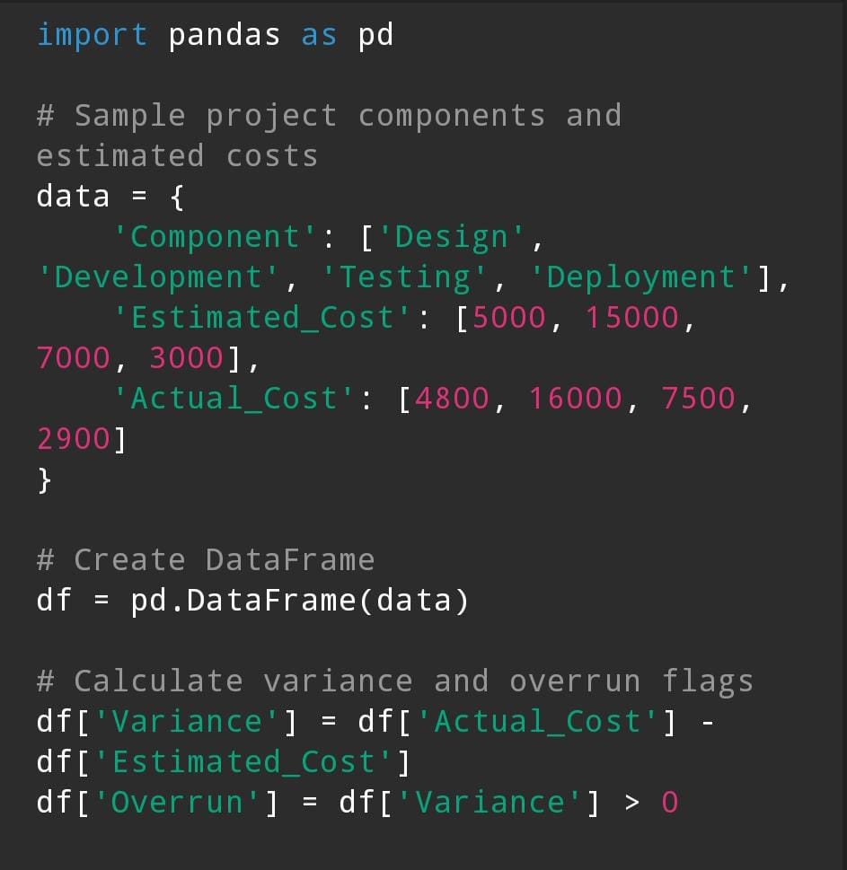

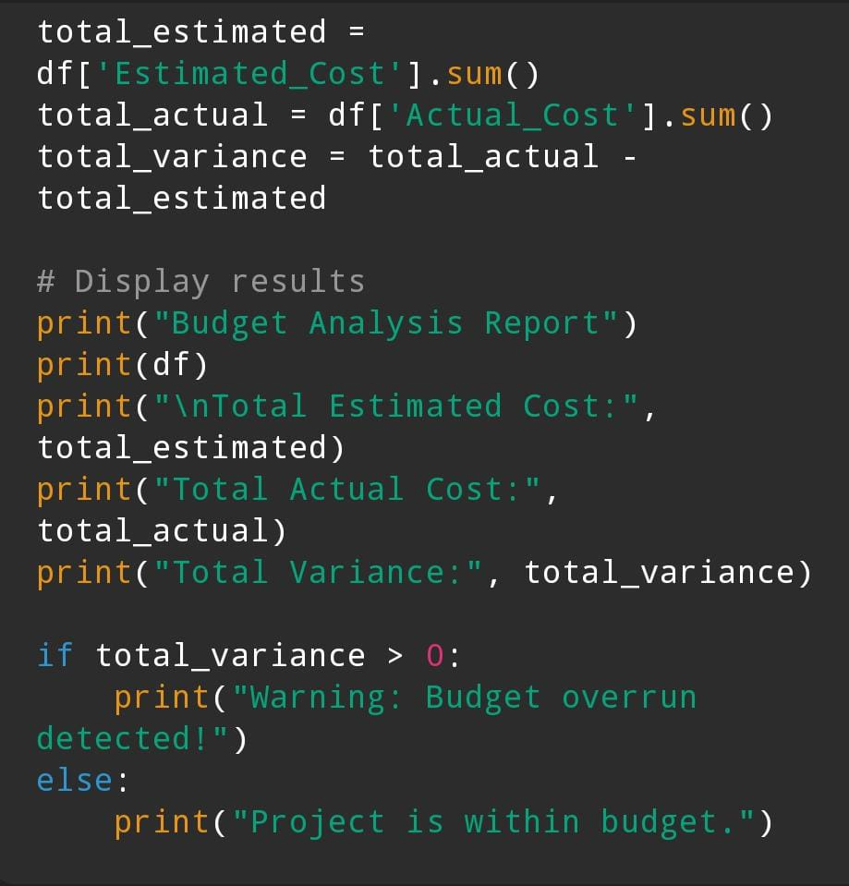

**Outcome**

